

LEARNER GUIDE
CPCCBS6101- Research and Evaluate Construction Methods and Materials for Class 1 and 10 buildings
to Three Storeys

Table of Contents

This Learner Guide 1
CPCCBS6101 Research and evaluate construction methods and materials for Class 1 and 10 buildings to three storeys 1
A complete copy of the above unit of competency can be downloaded from the TGA website 1
About this Unit of Study Introduction 2
This Learner Guide Covers 2
Learning Program 2
Additional Learning Support 3
Facilitation 3
Flexible Learning 4
Space 4
Study Resources 4
Time 5
Study Strategies 6
Using this Learner Guide 7
How to Get the Most Out of Your Learner Guide 7
Additional Research, Reading, and Note-Taking 8
Introduction 9
Classes of Building Projects 9
Building and Construction Terminology 9
Foundation skills 13
  - – Research and Evaluate Construction Methods for Class 1 or 10 Buildings 14
  - Research information to identify traditional, new and emerging construction methods and conduct required checks to confirm the validity and reliability of gathered information 14
    - Concrete 15
    - Clay and Stone Products 17
    - Timber 18
    - Metal 21
    - Plastic 24
    - Glass 24
    - Internal Linings (Plaster, Fire Rated Protective Coverings) 25
    - Waterproof membranes, Sealants and Adhesives 26
  - Investigate and Evaluate Methods for Site Investigation and Preparation 28
    - Principles and practices of site establishment: drainage, earthworks and pest risk management 28
    - Soil investigation, assessment and clarification 30
  - Evaluate the application of different construction methods to structural elements,
components or systems for Class 1 or 10 buildings 32
    - Structural and supporting systems 32
      - Masonry systems 33
      - Systems for floors, roofs, sub-floor ventilation and walls 34
    - Enclosing systems 35
      - Glazing 35
      - Gutters and Downpipes 36
      - Roof and wall Cladding 36
    - Fire Safety 37
      - Clearances and Protection from heating appliances 37
      - Fire Separation 38
      - Requirements for Bush Fire 38
      - Smoke Alarms 39
    - Health and Amenity 40
      - Facilities 41
      - Sound Insulation 42
      - Ventilation 43
      - Wet Areas 44
    - Safe Movement and Access 44
      - Balustrades 45
      - Stair Construction 45
      - Swimming pool access 46
    - Energy Efficiency 46
      - Air movement 47
      - Building Fabric 47
      - Building Sealing and Insulation 48
      - External Glazing 48
      - Services 49
  - – Research and Evaluate Construction Materials for Class 1 or 10 buildings 50
  - Research information to identify traditional, new and emerging construction materials and conduct required checks to confirm the validity and reliability of gathered information 51
    - Clay Products 52
    - Timber 52
    - Metal 53
    - Plastics 53
    - Glass 53
    - Internal linings 54
    - Water proof membranes sealant and adhesives 54
  - Evaluate the application of different construction materials to structural elements, components or systems for Class 1 or 10 buildings 55
    - High wind area 55
    - Highly corrosive area (within 1 kilometre of the ocean) 55
    - Cyclone area 55
    - Earthquake area 55
    - Alpine area 56
2.2.5 Metropolitan area 56
  - – Research and Evaluate Service Provisions for Class 1 or 10 buildings 57
  - Research information to identify service requirements, compliance and installation
methods, and conduct required checks to confirm the validity and reliability of gathered data 57
  - Evaluate options for energy supply and infrastructure, heating and cooling systems, fire protection and gas and hydraulic service supply and infrastructure 58
  - Evaluate service systems and components in relation to different user groups, geographical locations and climatic conditions, and note strengths and weaknesses of each context. 58
Required Reading 58
  - – Report Research and Evaluate Outcomes 59
  - Prepare report containing research and evaluation finding, recommendations and supporting evidence for Class 1 or 10 buildings according to workplace requirements. 59
  - Distribute research and evaluation report to relevant persons for feedback 59
  - Implement information management procedures to maintain data currency and classify and store research 59
Importance of Establishing a Reliable Inspection Checklist for Buildings 61
References 63

This Learner Guide
CPCCBS6101 Research and evaluate construction methods and materials for Class 1 and 10 buildings to three storeys
This unit of competency specifies the skills and knowledge required to develop an understanding of traditional, new and emerging construction methods and materials, including systems and components for services, for Class 1 and 10 buildings as defined in the National Construction Code (NCC), and up to three storeys and not exceeding 2,000 square metres in floor area. It requires researching and evaluating construction industry information, including research papers, engineering reports, material specifications and performance data; and establishing information management procedures to maintain data currency, classify and store research information.
This unit is suitable for building surveyors who draw on their broad theoretical knowledge and technical skills to provide advisory code-consulting services or authorised statutory services relating to planning or building permit application assessment or building audit and inspection services for Class 1 and 10 buildings.
This unit forms part of the licensing requirements for building surveying in some states and territories. Relevant state and territory regulatory authorities should be consulted to clarify these requirements.
A complete copy of the above unit of competency can be downloaded from the TGA website:
https://training.gov.au/Training/Details/CPCCBS6101

Learner Guide Victoria University Building & Construction

About this Unit of Study Introduction
As a worker, a trainee, or a future worker, you want to enjoy your work and become known as a valuable team member. This unit of competency will help you acquire the knowledge and skills to work effectively as an individual and in groups. It will give you the basis to contribute to the goals of the organisation which employs you.
It is essential that you begin your training by becoming familiar with the industry standards to which organisations must conform.

This Learner Guide Covers
Research and evaluate construction methods and materials for Class 1 and 10 buildings to three storeys.
- Research and evaluate construction methods for Class 1 or 10 buildings.
- Research and evaluate construction materials for Class 1 or 10 buildings.
- Research and evaluate service provisions for Class 1 or 10 buildings.
- Report research and evaluation outcomes

Learning Program
As you progress through this unit of study, you will develop skills in locating and understanding an organisation’s policies and procedures. You will build up a sound knowledge of the industry standards within which organisations must operate. You will become more aware of the effect that your own skills in dealing with people have on your success or otherwise in the workplace. Knowledge of your skills and capabilities will help you make informed choices about your further study and career options.

Learner Guide Victoria University Building & Construction

Additional Learning Support
To obtain additional support, you may:
  - Search for other resources. You may find books, journals, videos and other materials which provide additional information about topics in this unit.
  - Search for other resources in your local library. Most libraries keep information about government departments and other organisations, services and programs. The librarian should be able to help you locate such resources.
  - Contact information services such as Infolink, Equal Opportunity Commission, Commissioner of Workplace Agreements, Union organisations, and public relations and information services provided by various government departments. Many of these services are listed in the telephone directory.
  - Contact your facilitator.

Facilitation
Your training organisation will provide you with a facilitator. Your facilitator will play an active role in supporting your learning. Your facilitator will help you at any time during working hours to assist with:
  - How and when to make contact,
  - what you need to do to complete this unit of study, and
  - What support will be provided.
Here are some of the things your facilitator may do to make your study easier:
  - Give you a clear visual timetable of events for the semester or term in which you are enrolled, including any deadlines for assessments.
  - Provide you with online webinar times and availability.
  - Use ‘action sheets’ to remind you about tasks you need to complete, and updates on websites.
  - Make themselves available by telephone for support discussion and provide you with industry updates by email where applicable.
  - Keep in touch with you during your studies.

Learner Guide Victoria University Building & Construction

Flexible Learning
Studying to become a competent worker is an interesting and exciting thing to do. You will learn about current issues in this area. You will establish relationships with other students, fellow workers, and clients. You will learn about your own ideas, attitudes, and values. You will also have fun. (Most of the time!)
At other times, studying can seem overwhelming and impossibly demanding, particularly when you have an assignment to do and you aren’t sure how to tackle it, your family and friends want you to spend time with them, or a movie you want to see is on television.
Sometimes being a student can be hard.
Here are some ideas to help you through the hard times. To study effectively, you need space, resources, and time.

Space
Try to set up a place at home or at work where:
- You can keep your study materials,
- you can be reasonably quiet and free from interruptions, and
- You can be reasonably comfortable, with good lighting, seating, and a flat surface for writing.
If it is impossible for you to set up a study space, perhaps you could use your local library. You will not be able to store your study materials there, but you will have quiet, a desk and chair, and easy access to the other facilities.

Study Resources
The most basic resources you will need are:
- A chair
- A desk or table
- A computer with Internet access
- A reading lamp or good light
- A folder or file to keep your notes and study materials together
- Materials to record information (pen and paper or notebooks, or a computer and printer)
- Reference materials, including a dictionary
Do not forget that other people can be valuable study resources. Your fellow workers, work supervisor, other students, your facilitator, your local librarian, and workers in this area can also help you.

Learner Guide Victoria University Building & Construction

Time
It is important to plan your study time. Work out a time that suits you and plan around it. Most people find that studying, in short, concentrated blocks of time (an hour or two) at regular intervals (daily, every second day, once a week) is more effective than trying to cram a lot of learning into a whole day. You need time to ‘digest’ the information in one section before you move on to the next, and everyone needs regular breaks from study to avoid overload. Be realistic in allocating time for study. Look at what is required for the unit and look at your other commitments.
Make up a study timetable and stick to it. Build in ‘deadlines’ and set yourself goals for completing study tasks. Allow time for reading and completing activities. Remember that it is the quality of the time you spend studying rather than the quantity that is important.

Learner Guide Victoria University Building & Construction

Study Strategies
Different people have different learning ‘styles’. Some people learn best by listening or repeating things out loud. Some learn best by ‘doing’, some by reading and making notes. Assess your own learning style and try to identify any barriers to learning which might affect you. Are you easily distracted? Are you afraid you will fail? Are you taking study too seriously? Not seriously enough? Do you have supportive friends and family? Here are some ideas for effective study strategies:
- Make notes. This often helps you to remember new or unfamiliar information. Do not worry about spelling or neatness, as long as you can read your own notes. Keep your notes with the rest of your study materials and add to them as you go. Use pictures and diagrams if this helps.
- Underline keywords when you are reading the materials in this Learner Guide. (Do not underline things in other people’s books.) This also helps you to remember important points.
- Talk to other people (fellow workers, fellow students, friends, family, or your facilitator) about what you are learning. As well as help you to clarify and understand new ideas, talking also gives you a chance to find out extra information and to get fresh ideas and different points of view.


Learner Guide Victoria University Building & Construction

Using this Learner Guide
A Learner Guide is just that, a guide to help you learn. A Learner Guide is not a textbook. Your Learner Guide will:
- Describe the skills you need to demonstrate to achieve competency for this unit.
- Provide information and knowledge to help you develop your skills.
- Provide you with structured learning activities to help you absorb knowledge and information and practice your skills.
- Direct you to other sources of additional knowledge and information about topics for this unit.

How to Get the Most Out of Your Learner Guide
Some sections are quite long and cover complex ideas and information. If you come across anything you do not understand:
- Talk to your facilitator.
- Research the area using the books and materials listed under Resources.
- Discuss the issue with other people (your workplace supervisor, fellow workers and fellow students).
- Try to relate the information presented in this Learner Guide to your own experience and to what you already know.
- Ask yourself questions as you go. For example, ‘Have I seen this happening anywhere?’ ‘Could this apply to me?’ ‘What if...’ This will help you to ‘make sense’ of new material, and to build on your existing knowledge.
- Talk to people about your study. Talking is a great way to reinforce what you are learning.
- Make notes.
- Work through the activities. Even if you are tempted to skip some activities, do them anyway. They are there for a reason, and even if you already have the knowledge or skills relating to a particular activity, doing them will help to reinforce what you already know. If you do not understand an activity, think carefully about the way the questions or instructions are phrased. Read the section again to see if you can make sense of it. If you are still confused, contact your facilitator or discuss the activity with other students, fellow workers or with your workplace supervisor.

Learner Guide Victoria University Building & Construction

Additional Research, Reading, and Note-Taking
If you are using the additional references and resources suggested in the Learner Guide to take your knowledge a step further, there are a few simple things to keep in mind to make this kind of research easier.
Always make a note of the author’s name, the title of the book or article, the edition, when it was published, where it was published, and the name of the publisher. This includes online articles. If you are taking notes about specific ideas or information, you will need to put the page number as well. This is called the reference information. You will need this for some assessment tasks, and it will help you to find the book again if you need to.
Keep your notes short and to the point. Relate your notes to the material in your Learner Guide. Put things into your own words. This will give you a better understanding of the material.
Start off with a question you want answered when you are exploring additional resource materials. This will structure your reading and save you time.

Learner Guide Victoria University Building & Construction

Introduction
The ‘construction process’ (sometimes referred to as the ‘construction phase’) is the physical construction, landscaping, or renovation phases, plus all related operations, such as demolition, site clearing, administration, etc. This is not to be confused with construction techniques, which are used to effectively accomplish a construction method or goal. An example of a construction technique is masonry.
This learner guide will cover the necessary information for you to understand and gain the knowledge to research and evaluate construction methods, materials and service provisions for Class 1 and 10 buildings to three storeys.
In this learner guide, you will learn to report evaluation outcomes for various Class 1 and 10 buildings.

Classes of Building Projects
For buildings, there are multiple classes of construction. The building classification and the form of construction will differ from the standard models. It is possible to have compromises that alter the kind of building. Concessions may be linked to the building's architecture, its size, and the number of escapes.
The classes relevant to this unit are only Classes 1 and 10.

Building and Construction Terminology
It is important to know some key building and construction terms and definitions to understand some of the information that you may encounter while taking the unit or in your workplace. The table below contains a list of terms and their definitions. It is significant to note that it is not an exhaustive list, and you are expected to undertake your own research at times if there are definitions that you need to clarify.

Term | Definition
Agreement | a contract between two or more parties, either written or verbal
Allotment | A part of land bounded by boundaries and is referenced by a Certificate of Title
Australian Standard | the approved standard for material, equipment, technique, or procedure as set down by the Standards Association of Australia (SAA)

Learner Guide Victoria University Building & Construction

Term | Definition
Admixture | Materials added to mortar or concrete to achieve particular modifications to the normal properties of the basic material
Brace | a member, usually a diagonal, which resists lateral loads and/or movements of a structure
Building trades | All trades which have a part in the construction of a building
Buttress | Normally masonry and provides lateral support to a wall
Carpentry | trade of preparing, cutting, and fixing timber in building construction
Cladding | any material used to face a building or structure
Contractor | one who agrees by written agreement or contract to supply materials and perform certain types of work for a specified sum of money
Curing | treatment of concrete or cement rendering to facilitate hardening also referred to as hydration
Datum | a predetermined level on a site from which all other levels are established
Dimension | a measure of distance
Due Diligence | Investigation or exercise of care a reasonable person should take
Flush | a smooth-faced door, no step between surfaces.
Gable | the triangular end of a house formed at the end of a pitched roof, from eaves level to apex
Housing | recess cut across the face of a piece of timber to receive the end of another piece
Masonry | brick, concrete, stone, artificial stone or terra cotta laid in mortar
Mortar | a composition of lime and/or cement and sand mixed with water in various proportions

Learner Guide Victoria University Building & Construction

Mpa | Mega Pascal, measurement of Pressure. Pressure kPa = Force kN/Area m2
Nogging | a horizontal piece of timber fixed between studs in a framed wall
Pane | single piece of glass in a window or door
Piers | Footings: a mass concrete to transfer load spread to a deeper foundation  Walls: Masonry pier to provide lateral support or support in the subfloor to a bearer.
Pilot hole | a hole drilled to receive a nail or a screw
Plant | Tools and equipment used in building operations
Plumb | vertical or perpendicular
Potable | Storage of drinkable water
Porous | Liquid can pass through (due to very small air pockets)
Profile | a frame set up on a building site to assist the bricklayer to position a brick wall
Propped | Supported vertically or laterally.
Reduced level | elevation of a point relative to a given datum
Sanding | the smoothing down of visible timber or other surfaces with sandpaper
Scaffolding | a temporary structure specifically erected to support access platforms or working platforms
Site | The location on the allotment where the building will be situated
Slump | How workable the concrete is, measured with a cone test. Indicates the strength of the concrete
Strip flooring | Flooring laid as separate boards, fitting together with a tongue on one edge and a mating grove on the other
Substrate | An internal lining used to support tiling or other finished surface

Learner Guide Victoria University Building & Construction

Tamp | to pound down or consolidate material
Waterproof | materials and construction which will prevent water from passing through walls and joints
Add words

Learner Guide Victoria University Building & Construction

Foundation skills
As part of this unit, you are expected to analyse non-conforming construction methods, define key problems, and produce an appropriate solution. You must seek clarification of the appropriate solution to meet construction method compliance.
You are expected to use digital tools and devices to communicate and collaborate effectively with others and demonstrate your ability to do so through the assessment process.
Digital tools and devices that you may be expected to use include the following:
- Email software and services
- Word processing software
- Computers
- Spreadsheet software
You are also expected to use equipment and programs to access, extract information, and develop relevant documentation. This may include researching the internet to access legislation, building codes, and other standards.



Learner Guide Victoria University Building & Construction

– Research and Evaluate Construction Methods for Class 1 or 10 Buildings.
Building Construction is all about putting the right components in at the right time. There are different stages when these components must be checked. This chapter will introduce to you various construction Methods using traditional, new and emerging construction methods.

Chapter 1 will introduce the National Construction Code (NCC). The NCC provides the criteria for construction methods and the minimum technical requirements that building projects throughout Australia must follow.
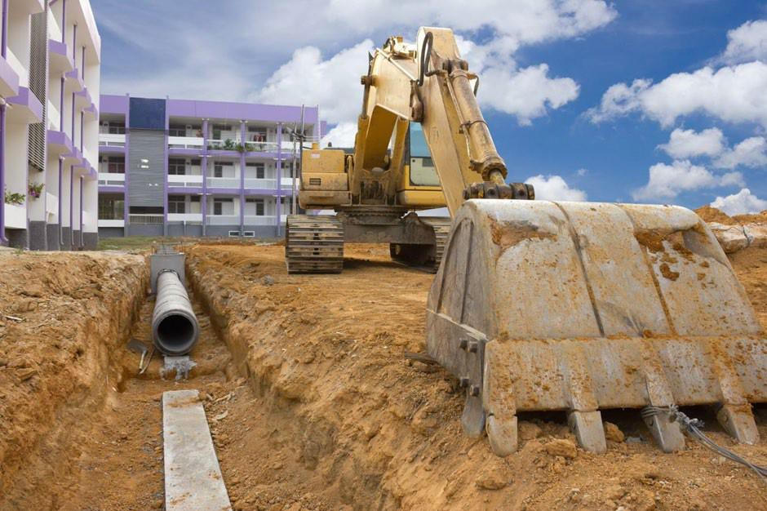

Research information to identify traditional, new and emerging construction methods and conduct required checks to confirm the validity and reliability of gathered information.
One major problem in the construction industry is the lack of time allocated to research new materials. Many organisations are now realizing that a component of research must be included during the design, assessment and construction phase. This will mitigate any possible future claims and allow innovation in the construction industry. Innovation can be a sustainable design, cost reducing or both. The lack of research has also been evident in many court decisions where it has been established that the practitioner could not have been

Learner Guide Victoria University Building & Construction

satisfied that the product or method had complied with the legislation. The court system is overwhelmed with various cases were due diligence was not evident.

Concrete
Part 4.2.10 – Housing Provisions 2022
Concrete is a construction material that has been around for thousands of years. It can be made on site or mixed at a batching plant and delivered to site via concrete truck and pump. The minimum strength of concrete is required to be grade N20 (20 Mpa). It requires to have a nominal slump of 100mm. Once concrete is made water should not be added to the mix as this will weaken the concrete. It must be compacted and cured with good building practice. Once the concrete is mixed it should be discharged from the truck within one and a half hours. Appropriate retarders can be added to the mixture to extend the one and a half hours. The concrete should be vibrated to remove all air pockets and ensure concrete is thoroughly around reinforcement.

Concrete is used for footing construction, walls, suspended floors and roofs. Concrete can also be used for retaining wall structures.
Required Reading
Concrete for Housing, click here to download AS2870 2011
Additional reading
Fundamentals of Residential Construction Chapter 6 Build your own Home Pages 80 to 108
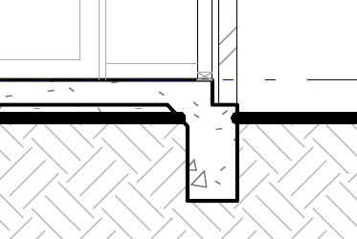

Learner Guide Victoria University Building & Construction

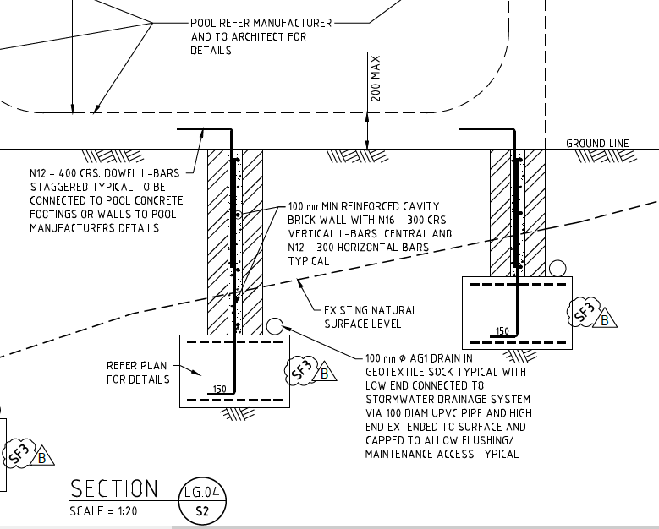

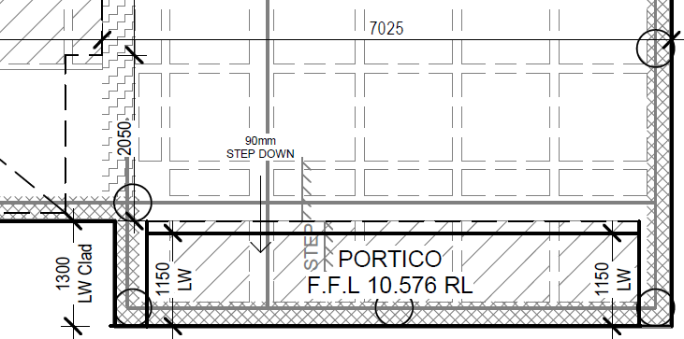

Learner Guide Victoria University Building & Construction

Clay and Stone Products
Clay products include bricks and roof tiles. Stone products include stone masonry, and stone finishes within the residential building. Masonry construction has been around for thousands of years. Although in the early days stone was used as the preferred method of construction, bricks were developed using clay and silts and became more popular forming certain patterns. The most common pattern around the world is stretcher bond. Despite significant technology changes, bricks are still laid one by one on top of each other. The bonding material, mortar has undergone significant changes in recent years but in principle remains the same. Masonry can be reinforced or unreinforced. It can be supported by piers and buttresses. Masonry is still the most common external wall used throughout Australia.
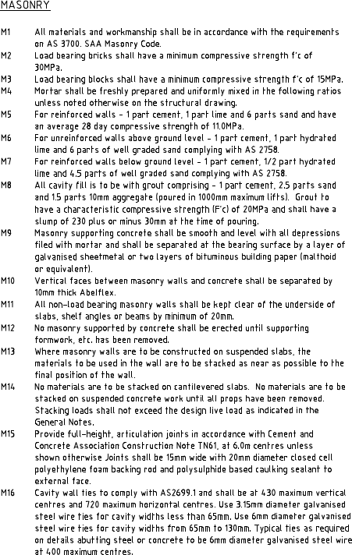

Learner Guide Victoria University Building & Construction

Required Reading
AS4773 2015 Part 1 Masonry in small buildings — Design AS4773 2015 Part 2 Masonry in small buildings — Construction AS 2049 2002 Roof tiles
AS 2050 2018 Installation of roof tiles
The Brickwork Manual, click here to download
Construction Guidelines for Clay Masonry, click here to download Technical Note 61, click here to download
Additional Reading
AS3700 2018 Masonry structures
The Properties of Roof Tiles, click here to download Fundamentals of Residential Construction Chapter 5 Build your own Home Pages 117 and 128

Timber
Timber is another construction material that has a long history. Timber has evolved very quickly in the last 100 years. With the introduction in the 1950’s with brick veneer construction, timber took a leading role in construction. Cross Laminated Timber (CLT) continues to innovate construction methods. Timber frames can either be prefabricated off site and delivered to site or constructed on site. More commonly the floor systems and generally wall systems are constructed on site (excluding trusses) and the carpentry team will construct and position the walls in the appropriate location. The walls are constructed on a level surface (normally the floor of the home) and lifted and propped (temporary bracing) into positioned. They are plumbed and connected with other walls. Part of the construction of the wall will include permanent bracing. The length and type of bracing will depend on the wind category and the design of the building (heights, widths and roof pitch). Internal walls may require bracing and will require appropriate connections to the bottom and top plates. Wall frames include lintels for window openings, jamb studs to support lintels, common studs and noggins to stiffen the studs, a bottom and a top plate. Sometimes a ribbon plate (second top plate) is used to ensure the load path from the roof (truss) is maintained. In some cases an additional stud may be required to take concentrated loads or point loads from the roof (truncated girder truss or girder truss).

Learner Guide Victoria University Building & Construction

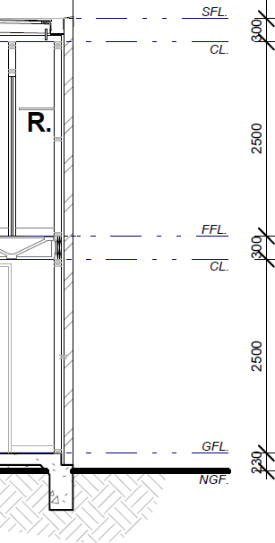

Learner Guide Victoria University Building & Construction

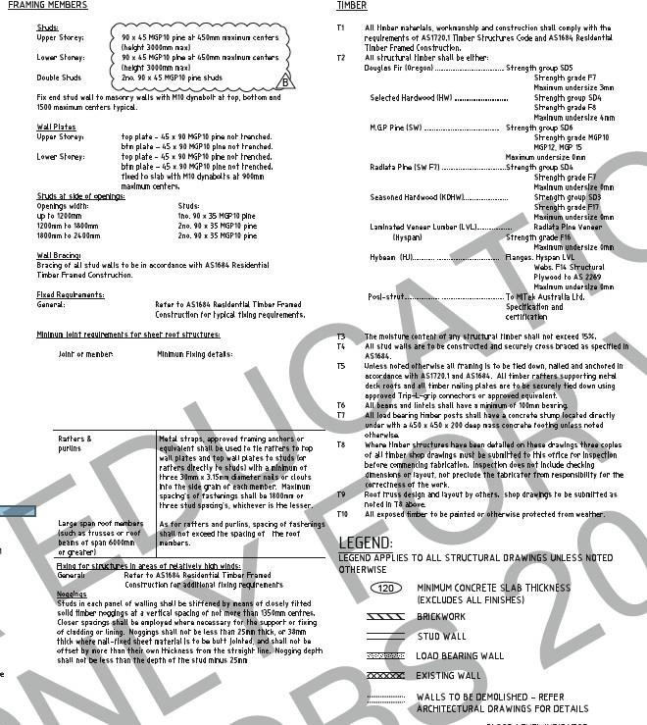

Learner Guide Victoria University Building & Construction

Required Reading
AS1684.2 2010 Residential timber-framed construction — Non-cyclonic areas
Timber-framed Construction for Townhouse Buildings Class 1a, click here to download

Additional Reading

AS1684.4 2010 Residential timber-framed construction — Simplified — Non-cyclonic areas AS1684.3 2010 Residential timber-framed construction — Cyclonic area
Fundamentals of Residential Construction Chapter 9, 10 and 25
Build your own Home Pages 98 and 99, 152 to 168

Metal
Metal is used widely in construction process. It is used in floor wall and roof construction. It is used in structural supporting systems such as piles, columns and beams. It is used for cladding systems and reinforcing for concrete. Many services are provided to the building using metal components.
Metals can be mixed to form various alloys to make components in the building or the metal can be used to protect other metals from corroding.
Care needs to be taken with combining dissimilar metals because of their galvanic relationship (discussed in Chapter2). Lead flashings shouldn’t be used when collecting potable water. Metals can be used for stair and balustrading construction. Metal is also used for formwork and falsework in construction.

Learner Guide Victoria University Building & Construction

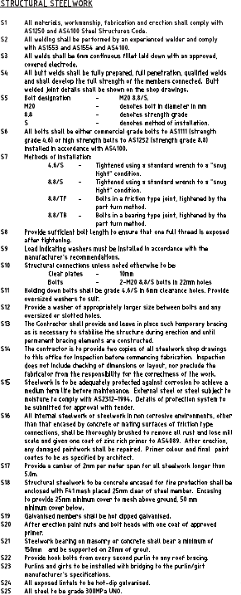

Learner Guide Victoria University Building & Construction

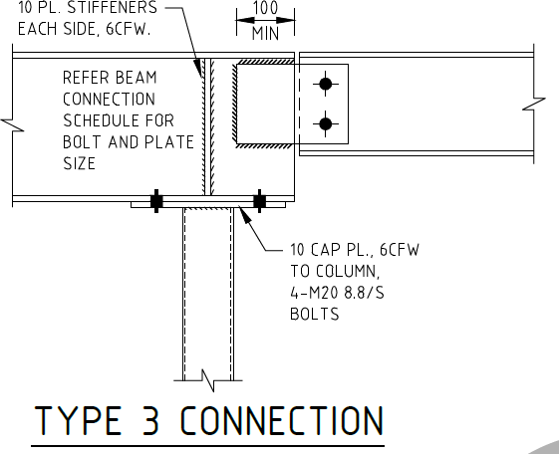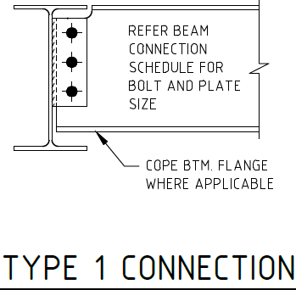

Required Reading
ASI TN007 Compliance Issues and Steel Structures, Click here to download ASI TN009 Documentation of Structural Steel, Click here to download
ASI TN014 Structural steelwork certification in Australia, Click here to download NASH Standard Part 1 2005 Residential and Low-Rise Steel Framing — Design Criteria

Additional Reading
AS1397-2011 Continuous hot-dip metallic coated steel sheet and strip — Coatings of zinc and zinc alloyed with aluminium and magnesium
AS/NZS 2327-2017 Composite structures — Composite steel-concrete construction in buildings
NASH Standard 2014 Steel Framed Construction in Bushfire Areas
NASH Standard Part 2 2014 Residential and Low-Rise Steel Framing — Design Solutions Fundamentals of Residential Construction Chapter 26
Build your own Home Pages 100 and 115 to 116

Learner Guide Victoria University Building & Construction

Plastic

Plastic is used widely in construction process.
From membranes to windows and doors. Formwork and void formers for waffle pod is constructed of plastic material. Plastic bar chairs are used to support reinforcement in concrete construction. There has been some development in plastic reinforcement and researchers investigate to recycle plastic to reinforce concrete. Almost all services in a building will have plastic incorporated or often be entirely made of plastic. Seals and flashings are made from plastic. The properties of plastic make floor coverings and insulation a very useful product due to plastics low (if any) conductivity.
Plastic can take up to 1000 years to degrade. This has had a profound impact on our environment.

Required Reading
AS/NZS 1562 Part 3 1996 Design and installation of sheet roof and wall cladding — Plastic AS/NZS 4256 Part 1 1994 Plastic roof and wall cladding materials — General requirements
AS/NZS 4256 Part 2 1994 Plastic roof and wall cladding materials — Unplasticized polyvinyl chloride (uPVC) building sheets
AS/NZS 4256 Part 3 1994 Plastic roof and wall cladding materials — Glass fibre reinforced polyester (GRP)
AS/NZS 4256 Part 5 1996 Plastic roof and wall cladding materials — Polycarbonate Additional Reading
Fundamentals of Residential Construction Page 313, 315 to 316, 338, 354 to 369, 403, 423,
460, 466, 470, 479, 485, 488, 505, 582 to 585, Chapter 27,
Build your own Home Pages page 16, 180, 233, 236 and 238

Glass

Learner Guide Victoria University Building & Construction

Glass has undergone significant development in recent years. It has become one of the most preferred system of claddings in Australia. Although it allows in light some of the glazing systems are excellent thermal barriers. This is achieved by using double glass (and in some cases triple glass). The thermal performance of a window, door, or skylight depends on how well the glass and frame conduct heat (conduction or U value) and how well the glass and frame transmit heat from direct sunlight (the solar heat gain coefficient or SHGC).
Human impact with glazing is a concern and many children and adults end up at emergency from injuries related to glass.

Required Reading
AS 1288 2006 Glass in buildings — Selection and installation Your Home Glazing (website) – Click here to access Additional Reading
Fundamentals of Residential Construction Page 142 and Chapter 12, Build your own Home Pages page 16, 140 to 148

Internal Linings (Plaster, Fire Rated Protective Coverings)

Although plaster board is still one of the most dominating internal linings, there are still some builders who will provide timber or alternative linings. Plasterboard is generally 10mm thick and will require studs to be spaced not greater than 450mm centres. In some cases studs can be spaced at 600mm centres but the plaster board will need to be at least 12mm thick.
Fire rated plaster board has the thickness of 13 mm and 16mm. It is a denser board. The thicker the plaster the better the fire resistance. Care should be taken for the wall height because tested systems are limited to the tested prototype.
Cement sheet is common as a substrate for wet areas.

Required Reading
Gyprock Red Book, Click here to download
Guide to Standards and Tolerance - Click here to download

Additional Reading
Fundamentals of Residential Construction Chapter 19, Build your own Home Pages page 123 to 127

Learner Guide Victoria University Building & Construction

Waterproof membranes, Sealants and Adhesives
Water proof membranes should always be constructed in accordance with the manufactures guidelines and applied to the recommended substrate. AS 3740 has specific requirements for water proofing and water resistance. Waterproof membranes must be flexible to allow for seasonal movement with buildings and expansion and contraction.
One major failure of membranes is the junction between the wall and floor when the building moves. Often membranes are installed too thick and crack or are not provided with an appropriate bond breakers (at wall and floor junctions). Another critical spot is around penetrations for services.
Sealants are designed to close gaps between surfaces. They generally stop water to get through, but can also prevent dirt dust and air to get through. Adhesives make 2 surfaces to stick together. The flexibility of the sealant or adhesive will depend on the application. Generally, adhesives are less flexible than sealants. There are sealants that also prevent the spread of fire through service penetrations and gaps.

Required Reading
AS 3740: 2021 - Waterproofing of domestic wet areas
Chapter 14 Materials for Architects and Builders (provided in Collaborate as a reading)

Additional Reading
AS/NZS 4200 Part 1 2017 Pliable building membranes and underlays — Installation requirements
Fundamentals of Residential Construction Chapter 19, Build your own Home Pages page 123 to 127

Learner Guide Victoria University Building & Construction


Checkpoint! Let’s Review
- The Housing Provisions of the NCC are the deemed to satisfy DtS provisions for construction methods in Australia.
- The NCC is adopted by each states legislation system. Although States and Territories have different building legislation the process are very similar.
- An Appropriate Authority is an individual or entity with the statutory responsibility to approve building and plumbing and enforce relevant regulations.
- The NCC is a performance based document and there is provision to design an alternative (performance) solution for various situations.
- There are different methods and materials depending on the climate, bushfire, wind and alpine conditions the building is subjected to.

Learner Guide Victoria University Building & Construction

Investigate and Evaluate Methods for Site Investigation and Preparation.


Significant work will go into the preparation of a site prior to commencing construction. Sites will require detailed investigation. The foundation will need to be investigated. The site will need to be confirmed if it is subject to flooding, termites or bushfire. There are also planning issues that will require to be established and overlays and zonings will need to be checked.

Principles and practices of site establishment: drainage, earthworks and pest risk management

Correct site establishment will allow the construction of a building to be carried out safely and to avoid potential damage to adjoining structures and to the building itself. Damage could occur due to soil collapsing or subsiding. Poor drainage or inadequate consideration of heavy rain can lead to serious damage to structures on or adjoining a construction site. Adjoining property may need protection works and the Act prescribes the method of seeking adjoining owners consent. The adjoining owners consent and expert engineering advice may alter the method of construction.

Learner Guide Victoria University Building & Construction

The requirements in Part 3.1 of the NCC 2022 Housing Provisions refer to normal site conditions, Normal site conditions includes site classifications including A, S, M, H or E. If previous buildings or structures have been removed, this could affect the moisture conditions of the soil. If moisture conditions are unusually high or if the seasonal moisture expected is too low, this would be regarded as abnormal conditions. The deemed to satisfy provisions cannot be applied. However the performance requirements still apply, and the builder will need to seek an alternative (performance) solution. There could also be presence of drains, dams, channels, ponds or tanks. These items will need to be removed under the supervision of the engineer and an appropriate design for the footing system should be developed. Abnormal conditions should always be referred to by the structural engineer.
Site cut slope ratios must comply with Table 3.2.1. Un-retained embankment slope ratios. This can be modified by the structural engineer after consultation with the soil engineer.
Consideration should also be provided to fill near buildings and structures. Fill should be mechanically compacted in layers not exceeding 150mm. It should not exceed more than 2.0m in height from the natural ground level.
Retaining wall structures must comply with AS4678.

The Governing Requirements (also known as General Requirements of the NCC) are outlined in Section A of Volume One, Section 1 of Volume Two. These provide the rules and instructions for using and complying with the NCC, including the following:
- interpretation of the NCC
- referenced documents such as Australian Standards
- acceptance of design and construction (such as evidence of suitability and other related documentation)
- classification of buildings

The Performance Requirements sit at the top of the compliance hierarchy. These are requirements that state the minimum level of performance for buildings, plumbing, and drainage installations. Performance Requirements are qualitative statements that describe the needs of building occupants.

Learner Guide Victoria University Building & Construction

Soil investigation, assessment and clarification
Soil investigation is a critical step in the design phase. It informs the architect and structural engineer the process of the construction of the home. It allows the architect with consultation to the engineer to determine the efficient footing system, taking into account the clients requirements. The investigation is to establish the foundation material and an analysis on how the home will perform on the site.
All sites are classified in accordance with AS2870. Generally sites are classified in categories of how reactive the foundation materials is to moisture by expanding (drying and shrinking). A class A is most sand and rock sites with little or no ground movement from moisture changes. A class S is a slightly reactive clay sites with only slight ground movement from moisture changes. A class M is a moderately reactive clay or silt sites which can experience moderate ground movement from moisture changes. A class H is a highly reactive clay sites which can experience high ground movement from moisture changes. A class E is an extremely reactive clay sites which can experience extreme ground movement from moisture changes.

A “P” site generally signifies a problem site and may include soft soils, such as soft clay or silt or loose sands; landslip; mine subsidence; collapsing soils; soils subject to erosion; reactive sites subject to abnormal moisture conditions or sites which cannot be classified otherwise. Some states and territories also have their own codes relating to residential building and construction projects. Examples of these are the Queensland Development Code, South Australia (SA)’s residential development code, and Western Australia’s residential design codes.
Some of these codes are specific and only apply to the states and territories where they are made for in this instance.

Required Reading
AS 1289.6.3.3 1997 Methods of testing soils for engineering purposes — Method 6.3.3: Soil strength and consolidation tests — Determination of the penetration resistance of a soil — Perth sand penetrometer test
NCC Volume 2 Part 3.1 and Part 3.2 AS4687 2002 Earth-retaining structures Additional Reading
Fundamentals of Residential Construction Chapter 7 and 8 Build your own Home Chapter 25 to 28

Learner Guide Victoria University Building & Construction



Checkpoint! Let’s Review
- Australian Standards (AS) are documents that have been specifically created to outline the specifications that relate to building and construction procedures and products to ensure that they comply with safety and performance standards.
- Some AS are referenced in their entirety, while some are referenced only in part. If the AS is only referenced in part, then the other parts that are not referenced are considered irrelevant and have no authority.
- There are three categories of standards that are relevant in the building and construction industry: International standards, Regional standards, and National Standards.
Further Reading
For more information on standards used in Australia, you can visit the link below.
What is a Standard?

Learner Guide Victoria University Building & Construction

Evaluate the application of different construction methods to structural elements, components or systems for Class 1 or 10 buildings



Part 3 of NCC Volume 2 regulates all the systems applicable to Class 1 to Class 10 buildings. The systems include structural, enclosing, fire safety, health/ amenity, safe movement and energy efficiency.

Structural and supporting systems:
A building, during construction or use, must be able to sustain damage. At the same time, the structural system as a whole should remain stable. It must avoid causing damage to other properties.
A building must also be able to perform adequately against extreme or frequently repeated design actions. The NCC states that structural behaviours should not cause any type of amenity loss. It defines structural behaviours as elements such as deflections, creep, settlement, and vibration. It expects that the building adheres to a specific set of performance

Learner Guide Victoria University Building & Construction

attributes in relation to structural reliability. For example, a building is expected to withstand the effects of extreme wind or rain but is not expected to withstand the impact of a crashing aeroplane. The building should also be able to withstand deflections in beams and a maximum deflection should be with the tolerances of the Australian Standards. This can be different to a client’s expectation of an allowable deflection in say a floor. Some clients may not like the plates in the cupboard to rattle as you walk by.
Load paths from the top of the roof all the way to the foundation should not be broken.

Masonry systems
Masonry as a system can withstand extreme weather. Masonry is porous and requires a cavity to prevent moisture getting into the inner wall layer. Most masonry walls are constructed using a stretcher bond. There are many bonds including stack, Flemish, English and soldier. Wall ties are required and consideration should be given around openings and the type of metal used. Some metals can corrode with weather or if the site is located near the ocean. The manufacturing of bricks are very energy intensive and are normally high in greenhouse gas emissions. Some solid bricks can be recycled several times. There are convict manufactured bricks still in circulation. The modern wire cuts tend to break when renovating and can be recycled but normally not reused.
Required Reading
The Brickwork Manual, click here to download
Construction Guidelines for Clay Masonry, click here to download Technical Note 61, click here to download
Additional Reading
Fundamentals of Residential Construction Chapter 5 Build your own Home Pages 117 and 128

Learner Guide Victoria University Building & Construction

Systems for floors, roofs, sub-floor ventilation and walls
Floor systems have developed significantly over recent years. Floor joists such as posistruts and smart joists have replaced the conventional solid timber floor joist.

Roof systems in residential construction are commonly a truss system. In Australia, normally supporting a tile or sheet metal roof. Conventional roofs such as pitched and propped roofs are still used but not as common as they were 30 years ago. There is a constant desire to innovate roof systems and the latest innovation is the incorporation of green roofs. In an ever-changing climate, green roofs are proving to be efficient and necessary to maintain liveable temperatures within the home.
Subfloor ventilation systems are critical for removing moisture from beneath the house. If the moisture is not removed this can encourage termites and the rotting of the floor structure. If sufficient vents cannot be provided around the perimeter of the building (abutting garage, veranda or wall is on the boundary) then mechanical ventilation should be considered. This will be a performance solution.
Wall systems are generally required to support the roof, both laterally and vertically. Walls will incorporate lintels to maintain the load path. Walls are braced (temporary and permanent) to ensure the roof will not collapse.

Required Reading
NCC Housing provisions Part 6 - Framing
AS1684.2 2010 Residential timber-framed construction — Non-cyclonic areas
Timber-framed Construction for Townhouse Buildings Class 1a, click here to download Additional Reading
Fundamentals of Residential Construction Chapter 9, 10 and 25
Build your own Home Pages 98 and 99, 152 to 168

Learner Guide Victoria University Building & Construction

Enclosing systems:
Enclosing systems have been pushed to the limit with effects of climate change. An enclosing system is required to safeguard occupants from illness or injury and protect the building from damage caused by surface water, external moisture entering a building and the accumulation of internal moisture in a building.
Enclosing systems must also protect other properties from damage caused by redirected surface water and the discharge of swimming pool wastewater.

A roof and external wall must prevent the penetration of water that could cause unhealthy or dangerous conditions, loss of amenity for occupants, undue dampness and deterioration of building elements.

Required Reading
NCC Housing Provisions Part 7- Roof and wall cladding
Fundamentals of Residential Construction Chapter 11

Additional Reading
Build your own Home Chapter 45 to 50 and chapter 54

Glazing
Glazing is a fundamental requirement in Class 1 buildings. It provides natural light to habitable rooms and when opened will provide ventilation also. The enclosing system of glazing is required to keep the wind and moisture from entering the building. As glazing forms the enclosing system and is incorporated in the external wall, it is subjected to the same requirements and testing as an external wall is.

Required Reading
NCC Housing Provisions Part 8 - Glazing
AS 2047 2014

Additional Reading
Fundamentals of Residential Construction Chapter 12

Learner Guide Victoria University Building & Construction

Gutters and Downpipes
In recent times gutters, including box gutters, have undergone significant regulatory changes. It appears due to climate change and significant rainfall that some gutters are not coping.

Required Reading

Lysaght Roofing Walling Installation Manual Jul 2015 Chapter 6, Click here to download.

NCC Housing Provisions Part 7.4 – Gutters and downpipes

AS/NZS 3500 Part 3 2018 Plumbing and drainage — Stormwater drainage Fundamentals of Residential Construction Chapter 11

Roof and wall Cladding
As a system the roof and wall cladding is important and subjected to testing in accordance with AS 1562.1 for metal roofs and AS/NZS 1562.3 for plastic roofs. With metal roofs careful consideration of the types of accessories and flashings must be undertaken. It is always recommended that manufacturers’ guidelines must be complied with. Lead flashings should not be incorporated on roofs where water is stored for potable (drinking).
Roof tiling must comply with and if the roof is constructed with terracotta, fibre-cement, timber slates and shingles must comply with AS 4597.
Flashings are a critical component to all roofs and must incorporate anti-capillary breaks. Flashings are normally used with a roof and wall junction.

Required Reading
AS 2050
AS 4597
NCC Housing Provisions Part 7- Roof and wall cladding
AS 1562.1
AS/NZS 1562.3.

Additional Reading
Fundamentals of Residential Construction Chapter 11 and 13 Build your own Home Chapter 36 to 41

Learner Guide Victoria University Building & Construction

Fire Safety:
Fire safety is a major concern in Australia. Lives are still lost on a regular basis. Smoke detectors have played a major role in saving lives but there are many buildings with non-complying smoke detectors. The location of the smoke detectors will play a significant role in the safety of the occupants.

Required Reading
NCC Housing Provisions Part 9 – Fire Safety

Additional Reading
Fundamentals of Residential Construction Chapter 16 Build your own Home Chapter 56

Clearances and Protection from heating appliances
It is important to maintain clearances around heating appliances as this is one of the major causes of fires in homes. The flue must be tested in accordance with AS 2918. Appliances must also comply with AS 2918.

Required Reading
NCC Housing Provisions Part 12.4 – Heating appliances, chimneys and flues
AS 2918 2018 Domestic solid fuel burning appliances — Installation

Additional Reading
Fundamentals of Residential Construction Chapter 18 Build your own Home Chapter 63

Learner Guide Victoria University Building & Construction

Fire Separation
Fire separating walls can be masonry, light weight or a combination of both. Fire separating walls require a Fire resistance Level (FRL) of 60/60/60. This term will be explained in Chapter 2.

Required Reading
NCC Housing Provisions Part 9.2 – Fire separation of external walls
AS 1530 Part 1 Methods for fire tests on building materials, components and structures —
Combustibility test for materials

Additional Reading
Fundamentals of Residential Construction Chapter Build your own Home Chapter

Requirements for Bush Fire
It has been evident each year bush fires can be devastating. There are continual updates to the legislation as further research is undertaken. Bush fires zones are determined to understand the severity of a fire and the proposed building will need to be designed with the requirements of Australian Standards

Required Reading

Building Regulations NCC
Australian Standards

Additional Reading
Fundamentals of Residential Construction Chapter 7 and 8 Build your own Home Chapter 25 to 28
Hand Book

Learner Guide Victoria University Building & Construction

Smoke Alarms
Smoke alarms must be connected to mains power. They should be located near sleeping areas and be interconnected so if one alarm sounds then all will sound. They must be located in a position where the smoke can initiate the alarm. Placing them too close to a wall and ceiling junction may render them useless or delay the alarm causing precious seconds to be wasted.
In a Class 1b smoke detectors should be located in each room and be interconnected. The main parts of the building will also require coverage for the detectors. Consideration should be given to prevent false alarms. This includes not locating a smoke detector in a kitchen area.

Required Reading
AS 3786 Smoke alarms using scattered light, transmitted light or ionization
NCC Housing Provisions Part 9.5 - Smoke alarms and evacuation lighting.

Fire Rescue website. Access here
Handbook ABCB Located Here Fire Safety Verification Method Handbook

Additional Reading
Fundamentals of Residential Construction Build your own Home

Learner Guide Victoria University Building & Construction

Health and Amenity:
The health and amenity requirements are important requirement in Class 1 buildings. They incorporate light and ventilation, dampness and acoustics. There is also a requirement of what types of facilities should be incorporated in a home. Light is a requirement to prevent the growth of unwanted bacteria. Ventilation is important because oxygen must be replenished constantly and dampness in the home can evaporate. Dampness encourages unwanted bacteria to grow and may affect the structural integrity of some supporting elements. Acoustics has been incorporated in recent years due to the introduction of light weight materials for fire separating walls. To maintain a reasonable sleeping environment acoustics have become a significant contribution to the health and amenity of occupants where a shared wall is utilised.

Required Reading
Handbook ABCB Located Here
Handbooks required, Indoor air quality verification methods Handbook, Condensation in buildings Handbook, Sound transmission and insulation in buildings Handbook
Australian Standards NCC Housing Provisions Part 10 – Health and amenity

Additional Reading
Fundamentals of Residential Construction Chapter Build your own Home Chapter

Learner Guide Victoria University Building & Construction

Facilities
The basic facilities that must be provided in a class 1 building include a closet pan, shower, wash basin, laundry trough, space for a washing machine and somewhere to prepare food.

Required Reading
NCC Housing Provisions Part 10.4 - Facilities

Additional Reading

Fundamentals of Residential Construction Chapter Build your own Home Chapter
Light

The amount of light that is required in a habitable room is 10% of the floor area. The floor area is defined in the NCC and normally excludes spaces that are cupboards or walk in robes. The light entering the building is measured clear of any obstructions such as window mullions. Windows also needs to have access to natural light. An external structure (verandah, carport and the like) should not obstruct the natural light. Non habitable rooms can be illuminated with artificial light. Habitable rooms include living areas, dining areas, kitchen and bedrooms.

Required Reading
NCC Housing Provisions Part 10.5 - Light

Additional Reading
Fundamentals of Residential Construction Chapter ……… Build your own Home Chapter ………….

Learner Guide Victoria University Building & Construction

Sound Insulation
Sound insulation has had a profound impact on the amenity of occupants. Sound insulation is only required to separate walls. It has been a source of significant complaints to the authorities. Many occupants not realising that when windows are opened from different sole occupancy units, sound will travel. Sound has a variety of frequencies such as high pitch, normal and bass. High pitch and normal can be blocked with sufficient dense material but bass is transferred with vibrations and requires a break in the separating wall.

Required Reading
AS2499:2000
NCC Housing Provisions Part 10.7 - Sound insulation

Additional Reading

Handbook ABCB Located Here

Learner Guide Victoria University Building & Construction

Ventilation
Ventilation is a requirement of the NCC. 5% of the floor must be provided to openings to allow a clear unobstructed area for ventilation. Ventilation is required to remove toxins and excess moisture from the habitable room. Ventilation can be achieved via mechanical systems. Normally bathrooms and water closets are provided with exhaust fans to remove moisture and odours from the sanitary compartments

Required Reading
NCC Housing Provisions Part 10.6 -Ventilation Handbook ABCB Located Here

Learner Guide Victoria University Building & Construction

Wet Areas
Wet areas must prevent moisture to seep into the structure. Moisture will deteriorate the structural elements causing a failure. Moisture can encourage mould growth. There are areas that require water resistance and areas that will need water proofing (direct contact with water).
Required Reading
AS 3740 Waterproofing of domestic wet areas
NCC Housing Provisions Part 10.2 - Wet areas and external waterproofing

Safe Movement and Access:
Many people are admitted to hospital for injuries related to falling downstairs or where barriers were not provided. The provisions in the NCC are to reduce the likelihood of an accident.

Required Reading
AS 4586 Slip resistance classification of new pedestrian surface materials
AS/NZS 1170.1 Clause…. Structural design actions — Permanent, imposed and other actions NCC Housing Provisions Part 11 - Safe Movement and Access

Learner Guide Victoria University Building & Construction

Balustrades
Balustrades are required to resist the force of an adult walking into the balustrade. They should not facilitate climbing and there should be no large gaps (125mm) that would allow a baby to crawl through. Various materials can be used to construct the balustrade. From glass to iron. Timber and steel wire can be used. The NCC has restrictions on where certain balustrades are used. Certain balustrades should not facilitate a child to climb the balustrade. The height of a balustrade is 1.0m above the finished surface. Consideration should be given where furniture (small tables, large tables, chairs, pot plants and air conditioning equipment) is placed on a balcony that may facilitate a child climbing the balustrade.

Required Reading
AS/NZS 1170.1 Clause…. Structural design actions — Permanent, imposed and other actions NCC Housing Provisions Part 11 - Safe Movement and Access

Stair Construction
Stair construction includes riser (step) and going (tread) dimensions. Stair width and headroom clearance are also included. Handrail heights are 865mm and the stair must not be slippery.

Required Reading
AS 4586 Slip resistance classification of new pedestrian surface materials NCC Housing Provisions Part 11 - Safe Movement and Access

Additional Reading
Fundamentals of Residential Construction Chapter ………… Build your own Home Chapter ……………
ABCB Handbook ……………..

Learner Guide Victoria University Building & Construction

Swimming pool access
Swimming pool access has been an ongoing problem for many years. There is still an average of one child per month drowning in Australia. The legislation has been constantly changing to prevent deaths of children by accessing pools without supervision.

Required Reading
AS 1926.1 Swimming pool safety — Safety barriers for swimming pools
AS 1926.2 Swimming pool safety — Location of safety barriers for swimming pools AS 1926.3 Swimming pool safety — Water recirculation systems

H7D2 of NCC Volume Two for glazed barriers for swimming pool enclosures.

Energy Efficiency:
Energy efficiency in Class 1 buildings has had constant change in the legislation. A class 1 will soon (NCC 2022) be required to achieve 7 stars (currently 6 stars). Many existing houses are less than 3 stars. A house less than 3 stars will consume more energy to cool or keep it warm. When additions and alterations representing more than 50% of the existing volume of the building, the entire building will be required to be brought up to existing minimum requirement of the NCC. This can be difficult with existing roof and wall construction. It may require the existing building to have existing plaster to be removed, insulation installed and then re-plastered. Some windows may need to be replaced.

Required Reading
NCC Housing Provisions Part 13 – Energy Efficiency

Learner Guide Victoria University Building & Construction

Air movement
Air movement can provide comfort in a home at relatively low energy consumption. Depending on the climate zone there is a requirement to provide a fan. Sometimes this can be done with an evaporative cooler. In humid environments an evaporative cooler may not be effective as just the fan-only mode.

Required Reading

NCC Housing Provisions Part 13.5 Ceiling fans

Building Fabric
The building fabric has undergone significant legislation changes over recent years. It has provided challenges for regulators to ensure compliance with the changing requirements. There is soon to be yet another amendment to the NCC which will require homes to achieve a 7 star rating. The building fabric will need to be reassessed. The building fabric includes roofs, external walls and floors.

Required Reading
NCC Housing Provisions Part 13.2 - Building fabric

Learner Guide Victoria University Building & Construction

Building Sealing and Insulation
Building sealing is a fundamental requirement when it comes to reducing energy consumption. Reducing Energy will lead to a reduction of greenhouse gasses. Chimneys, flues, windows, doors and exhaust fans are common leakage points and require to be appropriately sealed. The junction of ceilings, walls and floors also need to be sealed. Evaporative coolers should be fitted with a self-closing damper.

Insulation forms part of the building fabric and is essential to achieve the required 6-star energy rating.

Required Reading
NCC Housing Provisions Part 13.4 - Building sealing

External Glazing
Assessing the performance of glazing requires the understanding of 2 factors. The SHGC (Solar Heat Gain Coefficient 0 to 1.0) and the total system U value (Thermal conductivity 0 to 10). The values will vary depending if heating is required and the climate zone the building is situated. In climate zones 2 to 8 with windows oriented to the north solar heat gains are favored and a high thermal resistance to keep the heat in is preferred.

Required Reading
NCC Housing Provisions Part 13.3 - External glazing

Learner Guide Victoria University Building & Construction

Services
The services in a home have changed significantly and continue to change. Hot water is often initially solar heated with gas or electric boosted. All heated or cooled service pipes require insulation. Cooling and heating ductwork will also require insulation.
Artificial lighting has also a restriction in a Class 1 building of 5W/m². Less on verandahs and Class 10 buildings.

Required Reading
NCC Housing Provisions Part 13.7 - Services

Learner Guide Victoria University Building & Construction

– Research and Evaluate Construction Materials for Class 1 or 10 buildings
The NCC is considered a performance-based code. It requires you to comply with the minimum level of health, safety, amenity, and sustainability set in the Performance Requirements. Still, it does not prescribe a specific method to attain those requirements. This means that you are given the freedom to choose the compliance option for your building project. You may choose among Performance Solutions, Deemed-to-Satisfy Solutions, or a combination of both.
Chapter 1 covered the methods of construction. This chapter will cover the material and its compliance requirements from the NCC, along with compliance options that are suitable for the project. It will also cover relevant documentation and evidence that you need to compile and complete. These documents will ensure that your chosen compliance method can comply with the relevant Performance Requirements.
You are expected to apply NCC Performance Requirements in relation to the design and construction of your building project. Examples will include:

    - concrete
    - clay products
    - timber
    - metal
    - plastics
    - glass
    - Internal linings (plaster)
    - Water proof membranes, sealants and adhesives

FRL Fire resistance level……………………………………….

Learner Guide Victoria University Building & Construction

Research information to identify traditional, new and emerging construction materials and conduct required checks to confirm the validity and reliability of gathered information.


Concrete
Concrete can be formed into many shapes while it is plastic (wet). It will need appropriate formwork and falsework to support it while it cures. The curing process is called hydration.
Concrete is made with cement, aggregate (fine and course) and water. The water cement ratio will determine the strength of the concrete. Concrete is an excellent performer when compression forces are applied to the material but does not perform well when under tension load (such as a suspended slab). Concrete will require in most cases to be reinforced.
Concrete can be tested with a compression machine or a cone test.
Concrete blocks are manufactured to various work face dimensions in an extensive range of widths, offering a wide choice of load-bearing capacity and level of insulation.
Required Reading
MATERIALS FOR ARCHITECTS AND BUILDERS Fourth edition ARTHUR LYONS Chapter 2 and 3 Concrete Basics – Download here

Learner Guide Victoria University Building & Construction

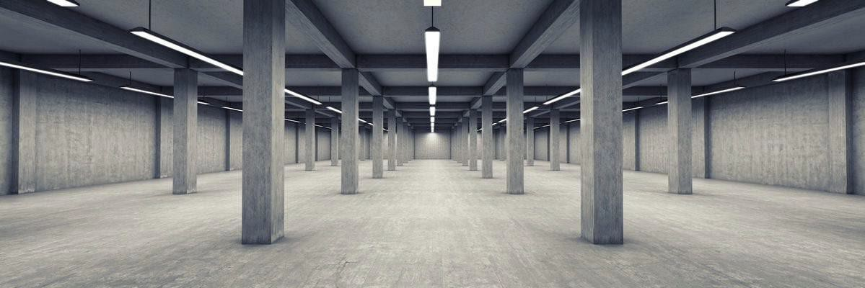

Clay Products
The wide range of clays suitable for brick making gives diversity to the products available. This variety is further increased by the effects of blending clays, the various forming processes, the application of surface finishes and the adjustment of firing conditions.

Require Reading
MATERIALS FOR ARCHITECTS AND BUILDERS Fourth edition ARTHUR LYONS Chapter 1

Timber
Timber is generally visually graded unless it is machine graded. Many products are made with engineered timber. Engineered timber includes Glulam and Cross laminated timber

Require Reading
MATERIALS FOR ARCHITECTS AND BUILDERS Fourth edition ARTHUR LYONS Chapter 4
Visual Stress grading Woodsolutions. Download here Machine Stress grading Woodsolutions. Download here CLT Download here

Learner Guide Victoria University Building & Construction

Metal
The most common metal used in construction is iron. Steel is made from a large portion of iron. Limestone and Coke are added. Alloy metals are created with metals such as manganese, nickel, chromium, carbon and vanadium. The different proportions of these metals added will produce different grades of steel. Nonmagnetic metals (also known as precious metals) can be used in many applications. These metals include copper, aluminium, brass, titanium, tungsten and lead. Other non-magnetic metals include gold and silver. Gold and silver are not common in construction.

Require Reading
MATERIALS FOR ARCHITECTS AND BUILDERS Fourth edition ARTHUR LYONS Chapter 5

Plastics
Plastics in construction are normally not structural. They generally are low density and UV light can make them brittle. Plastics are flammable and will emit noxious fumes in a fire. There are several different types of plastic. One of the most common is Polyvinyl chloride (PVC). This is due to pipes in buildings being manufactured from PVC. PVC is also used for electrical cable insulation, windows, doors and floor coverings. There are also foamed plastics that are used for thermal and acoustic insulation. Plastics can prevent the passage of air and water. This makes them very useful in construction. They are used for damp proof membranes, damp proof courses and vapour barriers. The manufacturing process consumes high energy and some plastics may take 1000+ years to degrade.

Require Reading
MATERIALS FOR ARCHITECTS AND BUILDERS Fourth edition ARTHUR LYONS Chapter 10

Glass
Glasses are manufactured in a large furnace. The sand is melted and runs on top of molten tin. The glass floats on top of the tin (float Glass). The glass eventually comes out of the furnace and begins the cooling process. The glass is then treated to form toughened glass or sheets are laminated together to increase the strength properties of the glass.

Require Reading
MATERIALS FOR ARCHITECTS AND BUILDERS Fourth edition ARTHUR LYONS Chapter 7

Learner Guide Victoria University Building & Construction

Internal linings
Rock gypsum is mined, crushed and ground to a fine powder. The natural mineral is normally white. Once it is heated the water is removed and it hardens.
are laminated together to increase the strength properties of the glass.

Require Reading

MATERIALS FOR ARCHITECTS AND BUILDERS Fourth edition ARTHUR LYONS Chapter 12

Water proof membranes sealant and adhesives
Sealants, gaskets and adhesives play a significant role in the success or failure of buildings. A combination of correct detailing and appropriate use of these materials is necessary to prevent the need for expensive remedial work.

Require Reading
MATERIALS FOR ARCHITECTS AND BUILDERS Fourth edition ARTHUR LYONS Chapter 14

Learner Guide Victoria University Building & Construction

Evaluate the application of different construction materials to structural elements, components or systems for Class 1 or 10 buildings.
To evaluate the application of all materials, it is important to identify and to understand the
areas various components or systems for Class 1 or 10 buildings will be located. The following areas will be discussed in detail:
High wind area
Highly corrosive area (within 1 kilometre of the ocean) Cyclone area
Earthquake area Alpine area Metropolitan area.

High wind area
High wind areas are N3 and N4 (Non-Cyclonic), these areas include sites that are not sheltered and located at the higher parts of hills. N1 and N2 are normally in well-sheltered areas and are normally in metropolitan areas. Buildings and structures within these areas require

Highly corrosive area (within 1 kilometre of the ocean)
A highly corrosive area can occur within 1 kilometre of breaking surf or within an industrial area. Metal, bricks and mortar may need protection in these areas

Cyclone area
Cyclone areas require substantial tie downs to ensure the structural integrity is not compromised. Cyclone areas are generally in the northern coastal areas of Queensland, Northern Territory, and Western Australia. They are categorised from C1 to C4 (Cyclonic) depending on the topography and exposure of the site. C4 is the highest category.

Earthquake area
Earthquakes are common all over the world. Depending on the risk factors within AS1170.4 residential buildings if adequately design for wind loads should be capable of withstanding earthquake loads. Flexibility is usually the main influence for buildings to withstand earthquake loads.

Learner Guide Victoria University Building & Construction

Alpine area
Alpine areas are generally 1200m above the Australian height datum (AHD). Alpine areas are normally subjected to snow loads and are likely also to be exposed to bushfires.

2.2.5 Metropolitan area
Metropolitan areas are more common for residential building construction. Common materials will often vary. Sydney and Perth is normally full brick masonry whereas Melbourne and Brisbane are masonry veneer (timber framed). Hobart is normally a timber framed construction with weatherboard cladding.

The selection of materials can depend on termites, wind loads and the availability of various materials. Victoria has a substantial area of pine plantations and many of the homes are constructed from MGP10 pine timber. Tasmania has a large supply of hard woods and most housing is entirely constructed from timber. Tasmania also due to the cooler climate is not subjected to termites.

Learner Guide Victoria University Building & Construction

– Research and Evaluate Service Provisions for Class 1 or 10 buildings
Connection services in buildings include:
    - Electricity
    - Sewer/septic
    - Water
    - Telecommunications
    - Gas
    - Storm water
Electricity will supply mechanical systems such as heating and cooling. Food preparation will require electricity, water and gas. Electricity can also include solar. Solar can also heat water and can be gas boosted.
Storm water can be stored in tanks or a retention system may be provided to reduce the impact on councils drainage system.
All services above are required to be installed by licensed trades.

Research information to identify service requirements, compliance and installation methods, and conduct required checks to confirm the validity and reliability of gathered data.
Licensed trades are required to provide certification after installing the required services. Building surveyors must review the relevant certificate and issue the relevant permit. All water and gas related appliances must be installed by a qualified plumber. Electrical appliances and services must be installed by a qualified electrician. Due to energy efficiency requirements relevant trades must be updated with ongoing changes in the NCC. The new services that now require installation include:

    - Solar panels
    - Stormwater tanks
    - Solar hot water
    - Room fans

Learner Guide Victoria University Building & Construction

Evaluate options for energy supply and infrastructure, heating and cooling systems, fire protection and gas and hydraulic service supply and infrastructure.
As climate change continues to influence the construction of housing, more and better forms of energy supply are considered. Renewable energy supply is often the preferred but cost of energy is also important. Providing energy efficient homes are only one part of the equation.
Infrastructure includes waste water management, water supply, gas supply, power supply and telecommunications.
The NCC is based on the expectations that many if not all the infrastructure services are available to class 1 and 10 buildings. Power, water and waste water are required for compliance with the NCC.

Evaluate service systems and components in relation to different user groups, geographical locations and climatic conditions, and note strengths and weaknesses of each context.
As service systems and components are evaluated geographical locations will play an important part in the selection of the services to be provided. The geographical locations will represent different climates. The same building can not simply be constructed in different climate zones. A service such as heating will not be required in geographical areas in the northern parts of Australia. Coastal areas will have other considerations of services. Different user groups can include high or medium density buildings where again consideration for services may change. It may be difficult to provide tank storage water for gardens and in some cases gardens may be limited. Other sources of energy savings may be required. Alpine areas may reach sub level temperatures and high temperatures depending on the season. Services may be completely different than a Metropolitan area. In many areas it is mandatory to connect to the local waste water system. In country areas providing a reliable sceptic system may be sufficient. Clean water is a basic expected requirement for a class 1 building, yet there are still parts of Australia that do not meet this basic requirement.

Required Reading
Yourhome.gov.au Energy Access here Yourhome.gov.au Water Access here Wilkie build your own home

Learner Guide Victoria University Building & Construction

– Report Research and Evaluate Outcomes

Prepare report containing research and evaluation finding, recommendations and supporting evidence for Class 1 or 10 buildings according to workplace requirements.
Certifiers are required to evaluate all the materials proposed in Class 1 and 10 buildings and when satisfied the methods and materials meet the required minimum standards are required to issue a building permit or provide certification to enable approval.

It is expected that during the evaluation appropriate enquiries will be undertaken. These enquiries may be directed to the applicant or in some cases they may research via the manufacturer’s documentation. The documentation may include test certificates from approved testing authorities, independent accreditation or they may rely on experts in the relevant area. A report will be required to be concise and explain where a component of the building may not comply with the regulations.

Distribute research and evaluation report to relevant persons for feedback
The report may primarily go to the applicant but often building surveyors/ certifiers are referring various matters to many reporting authorities. One of the major authorities is the local council. This may relate to various overlays from the planning scheme to simple requirements on where the storm water discharge is to be located. Other referral matters may include siting controls, termites, flood zones or bushfire zones. All of this information will need to be distributed to the relevant person to take the appropriate action.

Implement information management procedures to maintain data currency and classify and store research.
Many years ago councils kept various maps and libraries of fire test reports for various components in the industry. Much of this information is now digital and can be accessed via the internet. When certification is obtained at a particular time, the building surveyor may have made an assessment on the information available and certain decisions were made based on the current NCC and current Australian Standard. The client/designer/builder may have selected materials to meet the requirements of the tested prototype or material specified in the deemed to satisfy provisions (prescriptive requirements of the NCC and referenced Australian Standards

Learner Guide Victoria University Building & Construction

Fire Protection Inspection Checklist
This workplace safety checklist can be used by your maintenance team and safety committees as a go-to guide for learning how to conduct a complete building audit. You will learn to look for risks and hazards that can help prevent accidents and ensure compliance. Below is a sample checklist of items to check for during an inspection:

Item | Complies?
 | Yes | No
Evacuation routes
Evacuation routes clear of obstructions.
Final exits clear of obstruction for two metres on outside of doors.
Exit doors
Door hardware is the correct type (able to be opened by single downward hand motion by person evacuating through the door).
Each door along the fire exit route is unlocked and unobstructed (no deadbolts, etc.).
Fire/smoke doors
All fire/smoke doors are unobstructed and undamaged.
Current maintenance records for fire/smoke doors can be produced if requested.
Evacuation signs/diagrams
Evacuation signs/diagrams securely fastened to the wall surface.
Evacuation signs/diagrams visible and unobstructed.

Learner Guide Victoria University Building & Construction

Exit signs/emergency lighting
All emergency signs/emergency lighting is undamaged.
Current maintenance records for illuminated exit signs and emergency lighting can be produced if requested.
Fire appliances (extinguishers/hose reels/fire blankets)
All fire extinguishers correctly maintained and stamped.
All fire hose reels correctly maintained and stamped.
Fire detection and alarm system
Fire alarm panel is operating with no unexplained isolations or faults indicated.
Current maintenance records for alarm panel and smoke alarms can be produced.
Based on Fire safety audit checklist. © The State of Queensland 1995–2021
Take note that the checklist above is for guidance only. Not all sections may be applicable to all buildings, and some sections may have to be added.

Importance of Establishing a Reliable Inspection Checklist for Buildings
It is integral for a secure, efficient, and code-compliant building to have a proper building inspection process in place. Inspections not only show frequent wear and tear on construction elements but also alert occupants to hazardous building malfunctions that may cause a fire.
Although building features should be maintained throughout the year for proper functionality, in order to ensure compliance with organisational safety protocols, it is still necessary to put in place a real inspection process.
Here is a list of best practices to follow when your organisation puts an inspection process in place:
- To know what to look for when conducting an inspection, use a building inspection checklist.
- Pick an employee by a particular date and time to complete an inspection.

Learner Guide Victoria University Building & Construction

- To verify that the action has been taken care of by the agreed period, select a different employee.
- To create an audit trail, record all inspection results in a facility inspection program.
- If an inspection fails, elect a person to remedy the problem and give a definite deadline when the assignment should be completed.
- Provide consistent training sessions for all inspection team members throughout the year.
- Aggregate essential data for specialised inspectors, such as fire inspectors or insurance agents.
A cutting-edge yet easy-to-use interface can be provided by specialised inspection software, such as FireTraX and software developed by the company FireMate, that makes finishing inspections manageable for any industry. This specialised inspection software can be used to:
- Eliminate the hassle of organisational approaches based on paper.
- Track inspection histories by asset type automatically.
- Track past preventive measures for maintenance.
- Run current Inspection Data Analytics.
- Prove enforcement by supplying e-copies of paperwork to inspectors.
- Once procedures are finished, the maintenance team will be allowed to quickly generate inspection-related orders and close them out.
Based on Preparing for a Fire Safety Inspection. Telgian.

Learner Guide Victoria University Building & Construction

References
https://www.austlii.edu.au/cgi-bin/viewdb/au/cases/vic/VBAB/#
Abuhav, I. (2014, November 17). The PDCA cycle and the ISO 9001:2015 standard. ISO 9001 – Quality Management Knowledge Center. http://9001quality.com/plan-do-check-act-pcda-iso-9001/
AS 3600:2018 | NEW concrete building structures | SAI global. (2018, June 29). SAI Global; Standards Australia. https://infostore.saiglobal.com/en-au/Standards/AS-3600-2018-98877_SAIG_AS_AS_207930/
AS 4100:2020 steel structures. (2020, August 21). SAI Global; Standards Australia. https://infostore.saiglobal.com/en-au/standards/AS-4100-2020-122093_SAIG_AS_AS_2874063/
AS/NZS 4361.2:2017 guide to hazardous paint management lead paint. (2017, December 22). SAI Global; Standards Australia. https://infostore.saiglobal.com/en-au/standards/AS-NZS-4361-2-2017-99188_SAIG_AS_AS_208553/
Building and construction industry. (2020, November 13). Business.gov.au; Australian Government. https://www.business.gov.au/Planning/Industry-information/Building-and-construction-industry
Building classifications. (2020, July). Australian Building Codes Board. https://www.abcb.gov.au/Resources/Publications/Education-Training/Building-classifications
Changes to NCC 2019. update #1. (n.d.). Specialised Building Solutions. Retrieved March 9, 2021, from http://www.specialisedbuildingsolutions.com.au/changes-to-ncc-2019-update-1
CODE OF PRACTICE CONSTRUCTION WORK. (2019). In SafeWork NSW; NSW Government.
https://www.safework.nsw.gov.au/ data/assets/pdf_file/0014/52151/Constructio n-work-COP.pdf
Consequence of non-compliance. (n.d.). Australian Building and Construction Commission; Australian Government. Retrieved March 9, 2021, from https://www.abcc.gov.au/building-code/contractors/compliance-
code/consequence-non-compliance Construction glossary of building terms (2015).
https://www.residentialreports.com.au/wp-content/uploads/2015/03/Glossary-of- Building-Construction-Terminology.pdf

Learner Guide Victoria University Building & Construction

Construction work. (2020, October 13). NT WorkSafe; Northern Territory Government. https://worksafe.nt.gov.au/forms-and-resources/codes-of-practice/construction-work
Construction work code of practice - australian capital territory. (n.d.). Australian Business Licence and Information Service; Australian Government. Retrieved March 9, 2021, from https://ablis.business.gov.au/service/act/construction-work-code-of-practice/31145
Construction work: Code of practice. (2020, February 24). WorkSafe Tasmania; Tasmanian Government. https://worksafe.tas.gov.au/topics/laws-and-compliance/codes-of-practice/cop-folder/construction-work-code-of-practice
DEVELOPMENT OF PERFORMANCE SOLUTIONS. (n.d.). In Australian Building Codes Board. Retrieved March 9, 2021, from https://consultation.abcb.gov.au/engagement/developing-performance-solutions/user_uploads/guidancedocumentforperformancesolutions2016.pdf
Development regulations 2008. (2008). South Australian Legislation; Government of South Australia. https://www.legislation.sa.gov.au/LZ/C/R/Development%20Regulations%202008.as px
Environmental planning and assessment regulation 2000. (2000). NSW Legislation; NSW Government. https://www.legislation.nsw.gov.au/view/html/inforce/current/sl-2000-0557
Evidence of suitability. (2020, September). Australian Building Codes Board. https://www.abcb.gov.au/Resources/Publications/Education-Training/Evidence-of-Suitability
F.R.L. ratings. (n.d.). FTNSW. Retrieved March 9, 2021, from http://firetrainingnswelearning.com.au/information/f-r-l-ratings
Fire safety audit checklist. (2018). Queensland Government. https://education.qld.gov.au/initiativesstrategies/Documents/fire-safety-audit-checklist.DOCX
Home. (n.d.). WorkSafe Queensland; The State of Queensland. https://www.worksafe.qld.gov.au/
How the ABCC monitors compliance with the code. (n.d.). Australian Building and Construction Commission; Australian Government. Retrieved March 9, 2021, from https://www.abcc.gov.au/building-code/contractors/compliance-code/how-abcc-monitors-compliance-code

Learner Guide Victoria University Building & Construction

How to comply with the NCC. (n.d.). Australian Building Codes Board. Retrieved March 9, 2021, from https://www.abcb.gov.au/Resources/Publications/Education-Training/How-to-comply-with-the-NCC
National association of testing authorities, australia - home. (n.d.). National Association of Testing Authorities. Retrieved March 9, 2021, from https://www.nata.com.au/
Non-combustible material. (2020, September 1). Designing Buildings Wiki. https://www.designingbuildings.co.uk/wiki/Non-combustible_material
NT worksafe. (n.d.). NT WorkSafe; Northern Territory Government. Retrieved March 9, 2021, from http://www.worksafe.nt.gov.au/
Part 3.7.1 fire separation. (n.d.). Australian Building Codes Board. Retrieved March 9, 2021, from https://ncc.abcb.gov.au/ncc-online/NCC/2016-A1/NCC-2016-Volume-Two/Part-37-Fire-Safety/Part-371-Fire-Separation/Part-371-Fire-Separation?inlineLink=%7B5A67B005-9929-4773-87B8-04FFC1093723%7D
Performance solution process. (2020, July). Australian Building Codes Board. https://www.abcb.gov.au/Resources/Publications/Education-Training/performance-solution-process
Residential development code updates. (2021, February 22). Government of South Australia. https://www.sa.gov.au/topics/planning-and-property/land-and-property-development/building-and-property-development-applications/streamlined-residential-development/residential-development-code-updates
SafeWork NSW. (n.d.). SafeWork NSW; NSW Government. Retrieved March 9, 2021, from https://www.safework.nsw.gov.au/
SafeWork SA. (n.d.). SafeWork SA; Government of South Australia. Retrieved March 9, 2021, from https://www.safework.sa.gov.au/
Specification C1.1 fire-resisting construction. (2020). Australian Building Codes Board. https://ncc.abcb.gov.au/ncc-online/NCC/2016/NCC-2016-Volume-One/Section-C- Fire-Resistance/Specification-C11-FireResisting-Construction/1-Scope?inlineLink=%7BD9CCEF23-D426-4684-A5E6-F3B458B8B9AC%7D
Specification writing. (2020). In NATSPEC. https://www.natspec.com.au/images/PDF/Specification_Writing_Paper.pdf
TELGIAN HOLDINGS, INC. (2019, October 7). Preparing for a fire safety inspection: What you need to know. Telgian. https://www.telgian.com/preparing-fire-inspection/
Upgrading existing buildings. (2020, December). Australian Building Codes Board. https://www.abcb.gov.au/Resources/Publications/Education-Training/Upgrading-existing buildings

Learner Guide Victoria University Building & Construction

Using assessment methods. (n.d.). Australian Building Codes Board. Retrieved March 9, 2021, from https://www.abcb.gov.au/Resources/Publications/Education-Training/Assessment-Methods
What is a quality management system (QMS)? (n.d.). American Society for Quality. Retrieved March 9, 2021, from https://asq.org/quality-resources/quality-management-system
What is a standard? (n.d.). Standards Australia. Retrieved March 9, 2021, from https://www.standards.org.au/standards-development/what-is-standard
What is “building work” under the code? (n.d.). Australian Building and Construction Commission; Australian Government. Retrieved March 9, 2021, from https://www.abcc.gov.au/building-code/what-code/what-building-work-under-code
Wilber, J. (2020, June 17). What exactly is ISO certified? And why does it matter? Mead Metals, Inc. https://www.meadmetals.com/blog/what-exactly-is-iso-certified-and-what-does-it-mean
Work health and safety. (n.d.). Access Canberra; ACT Government. Retrieved March 9, 2021, from https://www.accesscanberra.act.gov.au/app/home/workhealthandsafety
Working drawing. (2021, March 3). Designing Buildings Wiki. https://www.designingbuildings.co.uk/wiki/Working_drawing
WorkSafe. (n.d.). Department of Mines, Industry Regulation and Safety; Government of Western Australia. Retrieved March 9, 2021, from https://www.commerce.wa.gov.au/worksafe
WorkSafe tasmania. (n.d.). WorkSafe Tasmania; Tasmanian Government. Retrieved March 9, 2021, from http://www.worksafe.tas.gov.au/
WorkSafe victoria - home - worksafe. (n.d.). WorkSafe Victoria; Victoria State Government.
Retrieved March 9, 2021, from http://www.worksafe.vic.gov.au/

Links

https://www.themanufacturer.com/articles/new-3d-graphene-structure-is-strongest-and-lightest-material-in-the-world/

Learner Guide Victoria University Building & Construction

